Apps and Websites
Below is a list of apps and websites that may be useful for you to support your child in the event of school closure or being stuck at home over the coming weeks.
Please note that these websites and apps are ones that have been suggested by staff or professionals we work with but the content has not been checked by the school. We do not recommend allowing young or vulnerable pupils to access websites and apps alone and would always recommend using them with a supervising adult.

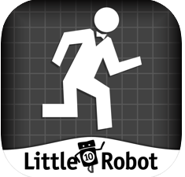
Maths

Operation math (paid app) - Defeat Dr. Odd and earn the latest spy gear by using addition, subtraction, multiplication and division.
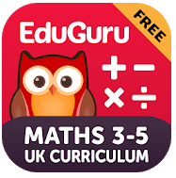
Edu Guru Maths / EduGuru English (paid app) – Maths and English games to support national Curriculum.
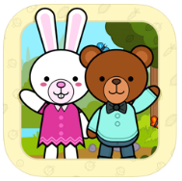
Vegetable Maths Masters – App designed to support maths and encourage healthy eating.
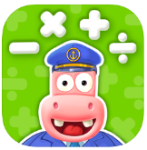

Splash math – Huge range of maths games (free with in app purchases)

English
Read with Biff, Chip and Kipper (by Gazoob)- PAID APP
Range of Oxford Reading Tree books that go right from stage 1. There is also additional questions, discussion ideas an a game at the end of each book.
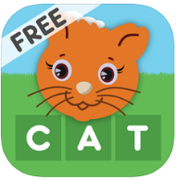
Build words using letter cards.

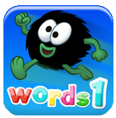

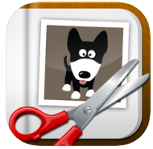
Learn 100 of the first high frequency sight words and help the Hairies jump to safety!

Little Story maker – Very simple story maker. Perfect for putting yourself into a story!

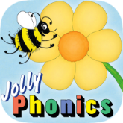
Jolly Phonics Letter Sounds (by Jolly Learning)
Jolly Phonics linked app that has activities such as sounding out, letter tracing. App is progressive (e.g. SATPIN must be completed before next set of sound is released).

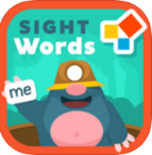
Sight word adventure (paid app) - a fun-filled adventure where children can learn to recognise, read, and write up to 320 sight words.

Sensory apps

Burp and Fart piano app (does what it says on the tin!)

Fireworks Lite: App that makes fireworks appear where you touch the screen.
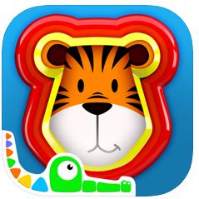 3D Shape Sorter: 3d shape sorter that can be rotated on screen to slot various shapes. (£0.99)
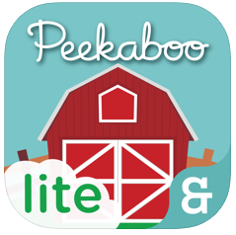 Peekaboo Lite: Explore the peekaboo barn, listen and guess which animals are hiding them find them!
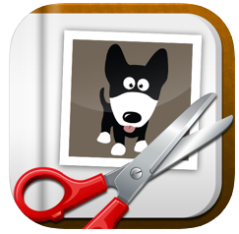 Little Story maker – Very simple story maker. Perfect for putting yourself into a story!
Do the Roar – Fine motor app. Tap shrek while he gets angrier and angrier, then clean up!

Computing
Websites for older pupils to work on coding skills:

https://www.j2e.com/j2code/

https://microbit.org/

https://studio.code.org/flappy/1

www.thinuknow.co.uk – Games and activities for pupils and parents to teach us to stay safe online.

BeetBot by TTS
Computing app that teaches programming through directing a ‘beebot’ around a garden.
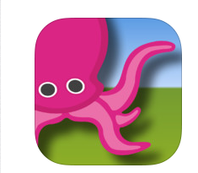

Green Screen (by Do Ink)

Green Screening app that allows you to upload background and foreground images, draw on images etc whilst adding a live video or picture.

Other apps and websites
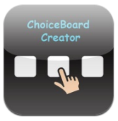
ChoiceBoard Creator (by Techno Chipmunk Innovations Inc)
Quick app to create choice boards. A correct annswer can also be assigned. Questions can be visual or auditory.
Epic! (by Epic! Creations Inc)
Reading app with unlimited reading books aimed at children 12 and under. Books for reading, picture books, first word/sentence books, audio books, ‘read to me’ books. Subscription required.
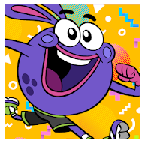
GoNoodle - Make screen time active with 300+ videos that feature kids songs, dance, yoga, mindfulness, stretching, and more!
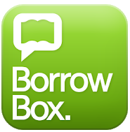

BORROWBOX - a free app which gives anyone who has a membership of the public library access to audio books and eBooks.

Website Subscriptions
www.twinkl.com CURRENTLY FREE
Resource website with thousands of worksheets, presentations and activities for pupils of all ages.
Twinkl have free access for parent resources for 30 days. Twinkl.co.uk/offer
Offer code: CVDTWINKLHELP

www.phonicsplay.co.uk CURRENTLY FREE
A huge range of Phonics games covering most of our school. Phonics play is offering free home membership while people remain in isolation. Highly recommended.

www.helpkidzlearn.com (subscription required)
Over 100 accessible learning activities which cater for a wide range of users with severe and complex needs, learning disabilities and are accesible by mouse and keyboard, one or two switches, touch and eye gaze.

https://www.thebestideasforkids.com/indoor-activities-for-kids/
Lots of ideas for keeping busy inside!

https://freddiesmummyuk.com/homeschooling-websites-uk/
Homeschooling resources

