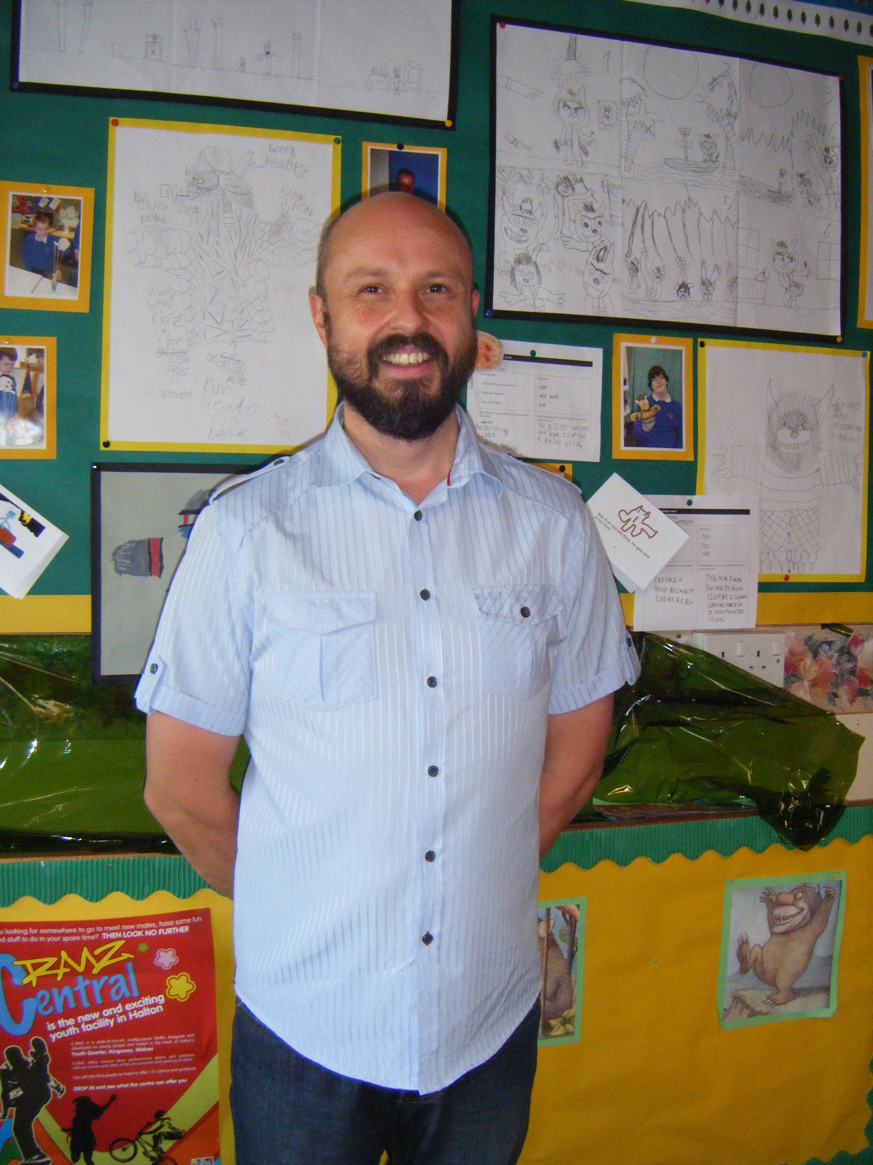
My involvement with Chesnut Lodge started back in 2010, when my daughter, Iona, attended the nursery. I became a Parent Governor in 2011 because I wanted to give something back to this wonderful school. I now serve as a co-opted Governor as well as Vice Chair to the Governing Body, Chair of the Premises Committee, and sit on several other committees. I have had experience of being a governor at another local school, and I believe this has provided me with a different perspective on education, which in turn aids me in helping the school to realise its goals.
Aside from this, I enjoy writing, reading, painting and photography, and have a great passion for all things Scottish.

