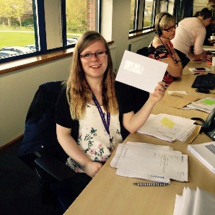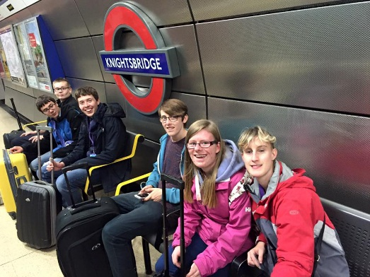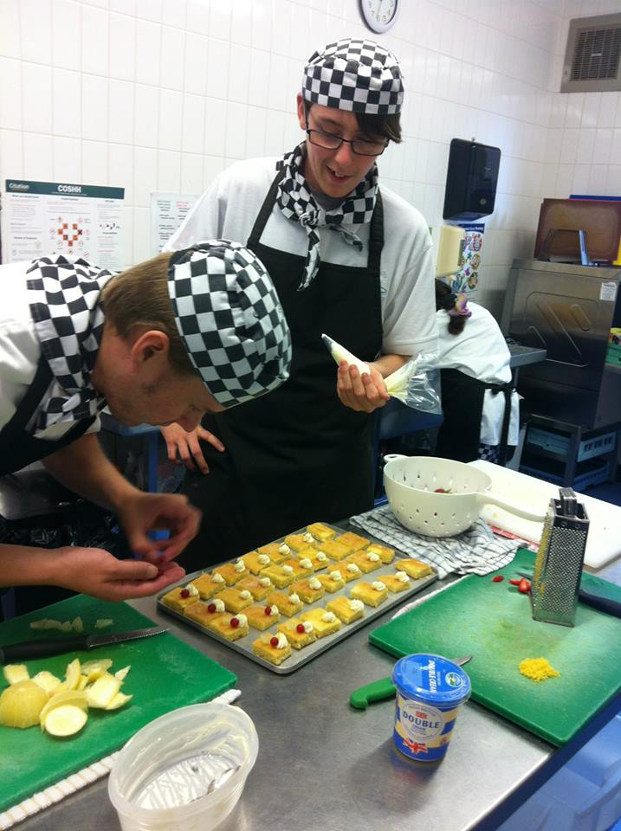

Decorated Christmas Cake Competition!

Enter our competition and bring in a bake from your school, class or as an individual.

Our Hospitality & Catering students will be cooking and serving a Christmas Lunch for £3.00 per person.

**Please book ahead if possible**

01606 889097

admin.pettypool@btconnect.com

Come and visit the College and Outdoor Centre. Open to Prospective Students, Parents, Carers, Schools, Colleges, Social Workers and Youth Services.......**Everyone is welcome.**

**Students will be running guided tours throughout the day.**

The Petty Pool Trust, Pool Lane, Sandiway, Nr Northwich CW8 2DR

**Thursday 24th November 2016 10am- 2pm**