Other tips and tricks for being stuck at home!

We've just heard a lovely idea for children stuck at home in the coming weeks. Why not share any artwork you have done by sticking it in the window! It might just brighten up someone else's day as they walk or drive past. Lost of people are also placing rainbows in the window so children can drive round an play spot the rainbows.
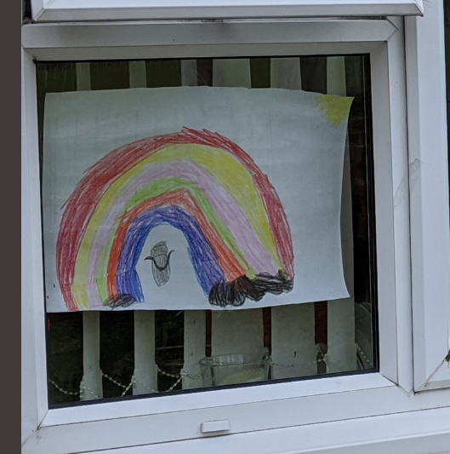

The Body Coach Joe Wicks will be doing ‘PE with Joe’ every morning at 9am.
https://www.youtube.com/playlist?list=PLyCLoPd4VxBvPHOpzoEk5onAEbq40g2-k

Cosmic Kids Yoga is a Youtube channel for Yoga activities.
https://www.youtube.com/user/CosmicKidsYoga

Sensory processing and Exercise Ideas:
Jump on a trampoline
Climbing activities
Ride a scooter or bike
Wear a heavy backpack
Carry shopping bags
Dance along to JustDance videos on Youtube
Using play dough

