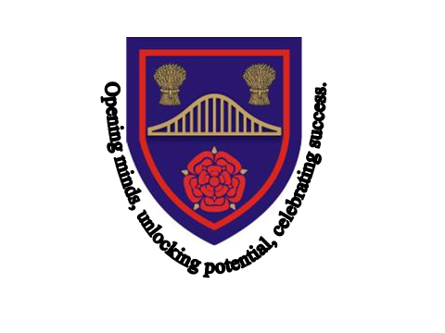
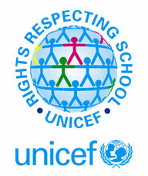
RIGHTS RESPECTING SCHOOL AWARD

Information leaflet
For Parents & Carers
Unicef is the world’s leading organisation working for children and their rights. In signing the UN Convention on the Rights of the Child all governments have a responsibility to make both children and adults aware of these rights.
The ‘Rights Respecting School’ Award will help our pupils to grow into confident, caring and responsible young citizens both in school and within the wider community.
By learning about their rights our children, also learn about the importance of respecting the rights of others i.e. their responsibilities.
The UN Convention on the Rights of the Child consists of 54 articles. The key provisions of the Convention are:
- The right to a childhood (including protection from harm)
- The right to be educated
- The right to be healthy (including having clean water, nutritious food and medical care)
- The right to be treated fairly (which includes changing laws and practices that discriminate against children)
- The right to be heard (which includes considering children’s views)

What is meant by rights?
These are not the same as wants. What are termed ‘rights’ are the basic human needs and values that apply - or should apply - to everyone.
What about responsibilities?
With rights come responsibilities. These include:
- For children: the responsibility to respect the rights of others
- For parents: to respect and provide for the rights of their children
- For schools: to support families and to respect and provide for the rights of children
What about children’s respect for the rights of others?
We think it’s important for children at Chesnut Lodge to learn about children in other
parts of the world whose rights may not be respected.
We have a responsibility to care about every child’s rights
How does teaching about children’s rights fit in with the aims of the school?
The aim of rights, respect and responsibilities and of the school is to help children in achieving their potential and become responsible citizens.
What is taught in the rights, respect and responsibilities curriculum helps children learn respect for self, others, critical thinking skills and informed decision making.
A Rights Respecting School is where:
- Pupils gain self esteem by learning about their rights
- Pupils learn that rights bring responsibilities for adults and children
- Pupils become active global citizens
- Pupils have a powerful voice
Every class at Chesnut Lodge has written a class charter which includes the rights and responsibilities that everyone in the class has agreed to.
How can parents support what children are learning about the Convention at school?
- Take the time to ask your child what he/she has learned recently regarding children’s rights.
- Discuss the ideas he/she is learning in class and try to think of examples from your own experiences, or from the media, of rights being respected or denied.
- Ask your child’s opinion on children’s rights
As with most things, the learning of rights, respect and responsibility begins at home. Children often learn what they see and hear.
By becoming involved in your child’s learning and showing an interest in who he/she is and what he/she is doing, you help your child to learn the importance of giving and sharing with others.
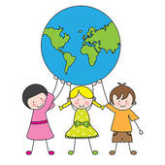
For more information visit:
www.unicef.org.uk/rrsa
Look out for further information and updates on our website
www.chesnutlodge.net

