Chesnut Lodge School

Reading at

home guide.

**Halton Libraries**

**Contact details:**

**Widnes Library**

**Victoria Road, Widnes, Cheshire. WA8 7QT**

**Telephone 0151 907 8383**



**Ditton Library**

**11 Queens Ave, Widnes, Cheshire. WA8 8HR**

**Telephone 0151 424 2459**

**Halton Lea Library**

**Halton Lea, Runcorn, Cheshire. WA7 2PF**

**Telephone 01928 715351**

www.halton.gov.uk/libraries

Dear Parents and Carers,

This guide to is to help you to support your children when they are reading at home.

Remember children need a number of strategies to learn to read. Different children learn in different ways. At school we encourage them to try a variety and any or all of these are perfectly acceptable;

**Sight vocabulary** – learning words by sight, this is particularly important with high frequency words that cannot be sounded out.

**Decoding** – sounding out words and then blending them together to hear the full word.

**Contextual clues** – reading the sentence to predict what the unfamiliar word could be, or looking at picture clues.

We hope you find reading this guide useful.

Chesnut Lodge School



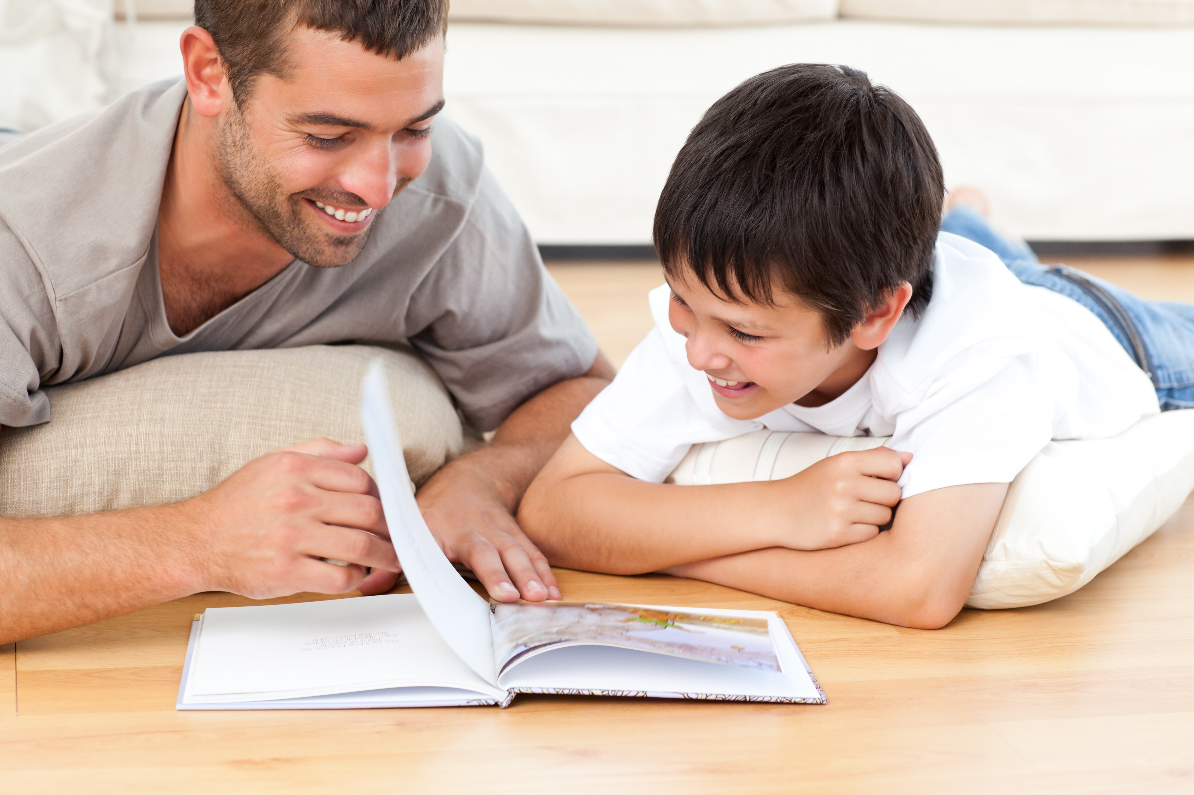

**A guide to reading with those able to decode.**

**To Begin**

Make sure your child has a comfortable, quiet place to sit. Distractions such as TV can make it difficult for children to concentrate. Give the book to your child for a few minutes so they can look at it alone. This allows the child to investigate and explore the text and pictures independently, before starting to read. Read the title together and ask them to tell you what they think before beginning. Remember talking about books is as important as reading them. Children need to have enthusiasm for texts so allow them to choose their own from the library as well as their school reading books.

Details of local libraries overleaf.

**Reading Aloud**

It is important that children are given the opportunity to read aloud to an adult as often as possible. This will improve their decoding and listening skills. Help your child to sound out and blend any unfamiliar words. If they are still unsure, read the word to them and explain what it means, then read the sentence again together. Remember to give lots of praise and tell them why they have done well, e.g. “I really enjoyed listening to that, because you made it sound so exciting!”

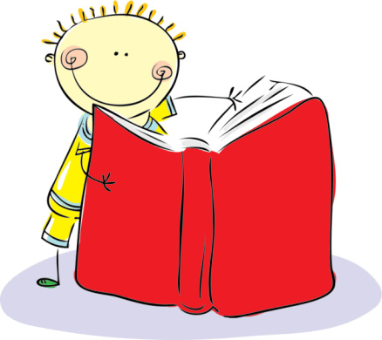

**Tips for reading with pre readers:**

* Put lots of expression into the words of the book you are sharing.

* Make the most of any rhymes and rhythms, make it fun.

* Please read and re-read the text. Your child will enjoy getting to know the words and any familiar rhymes and rhythms. Remember that we all enjoy hearing stories that we recognise.

* If your child can follow the pages as you read, point out the characters, or interesting objects in the illustrations.

* If appropriate and possible, link the text to something in your child’s life.

* Add sensory interest by using any textures, smells or tastes you can link to the story.

If you can use SIGNALONG, please do so to encourage understanding.

**Comprehension**

One of the most important parts of reading is comprehension. If a child decodes fluently, but does not fully understand the story or text, then they struggle to enjoy or appreciate books. It is therefore essential that children should be encouraged to answer questions about what they are reading.

At school we try to ensure that children are answering questions and talking about their book. One of the more crucial parts of reading is being able to conclude and infer ideas. Open questioning such as; ‘why do you think that happened?’ or ‘what makes you think that?’ will help with this. Asking children to tell you why or show you clues in the text/pictures can improve their inference skills dramatically.

Remember that children need to read a variety of texts such as stories, reports, information texts, poems, etc. They also love being read to by adults, particularly if you can do the voices! If you show children *you* enjoy reading it will have a very positive impact.

