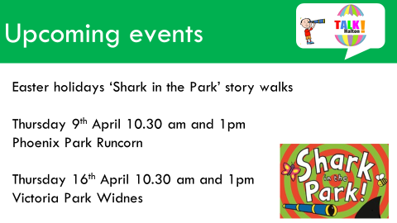
NO NEED TO BOOK ON TO THE TALK HALTON ‘SHARK IN THE PARK’ EVENTS

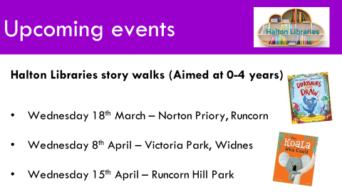
BOOK ON TO THE LIBRARY STORY WALKS THROUGH HALTON LIBRARIES

