Here are some of the rights of young people from the CRC
Article 1: everyone under the age of 18 have rights.
Article 5: everyone needs to know how to use their rights as they grow up.
Article 6: you have a right to life and be healthy.
Article 7: your right to a name and a nationality.

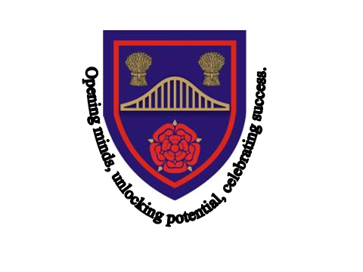
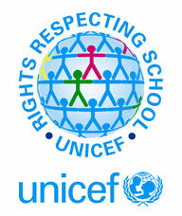

Chesnut Lodge is a Rights Respecting School!
In 1989, governments across the world promised all children the same rights by adopting the UN Convention on the rights of the Child.
The Convention says what countries must do so that all children grow as healthy as possible, can learn at school, are protected, have their views listened to, and are treated fairly.
At Chesnut Lodge, we currently hold the Silver Award (Level1) from UNICEF for our work on Children’s Rights. We are very proud of this and we feel it is important that everyone learns about and protects children’s rights.

Article 14: you have the right to follow your own religion.
Article 15: you have a right to meet with friends and join clubs.
Article 23: you have a right to special care and support if you are disabled.
Article 28: you have a right to come to school.
Article 31: you have a right to relax and have fun.

Our Rights Group
The members of the rights group represent all of the students and staff at Chesnut Lodge School. We believe all children should have the same rights. Our school community have learnt about rights and we know how important they are.
If you would like to join our group please speak to Sue Rathbone.
We meet every half term and action ways we can help people and make sure everybody knows about children’s rights.
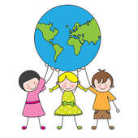
Children’s Rights are important to us all at Chesnut Lodge

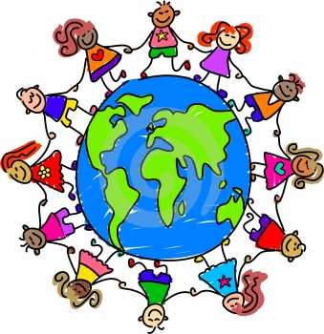

RRSA
Chesnut Lodge Rights Group
Information Leaflet

